A component is a function or class that returns JSX.

In the src make a “components” folder
NOTE : component name should compulsory PascalCase
NOTE : for every component have a separate CSS & JSX file(recommended) .

In the jsx file type “rafce” to create a functional component
const Navbar = () => {
return (
<div>Navbar</div>
)
}

In the app.jsx add the component(remember to import the component u add, to import ctrl+spacebar)
import React from 'react'
import Navbar from './components/navbar/Navbar'

const App = () => {
return (
<>
<Navbar /> //ctrl spacebar and import the Component
</>
)
}
NOTE : to import the component ctrl spacebar + enter

- React Component → The blueprint / function / class you define.
- React Element → The instance of the component that React will render. Example:

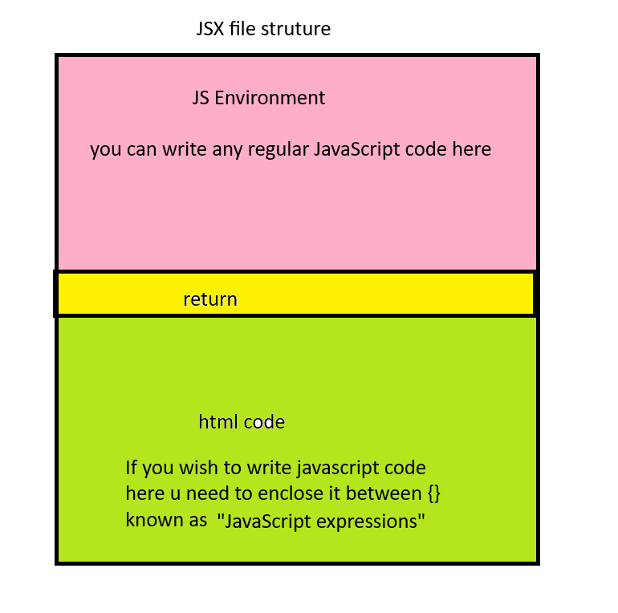
the js code written in jsx file should be written above the return statement
e.g console.log
all the manipulation part in the jsx should be done before the return after the return we can only read the values

Create List Component
Example 1:
const List = () => {

return (
<ul>
<li>A</li>
<li>B</li>
<li>C</li>
<li>D</li>
<li>E</li>
</ul>
)
}

Example 2:
const Test = () => {
return (
<div>
<ul>
<li>Delhi</li>
<li>Jaipur</li>
<li>Pune</li>
</ul>
</div>
)
}

Some more examples of writing HTML CSS code in jsx files

Option 3: use local Array + Map
const Test1 = () => {
const cities=["Apple","Jaipur","Pune","Mumbai"]
return (
<div>
<ul>
{
cities.map((city)=>(<li>{city}</li>))
}
</ul>
</div>
)
}

Option 4: Import Data from another file (String Array)
data.js
const cities=["Apple","Jaipur","Pune","Mumbai"]
export default cities

import cities from './data.js'

const Test1 = () => {
return (
<div>
<ul>
{
cities.map((city)=>(<li>{city}</li>))
}
</ul>
</div>
)
}

Option 5 : Import Data from another file (Array of Objects)
product.js put the data into this file and export
https://jsonplaceholder.typicode.com/users
https://fakestoreapi.com/products
https://fakestoreapiserver.reactbd.org/api/products

import products from '../data/products.js'
const Navbar = () => {

let categories=products.map(
(product)=>(product.category)
)
console.log(categories)

let uniqueCategories=new Set(categories)
console.log(uniqueCategories)

let categoryWithFurniture=[...uniqueCategories,'Furniture']

console.log(categoryWithFurniture)
return (
<div>
<ul>
{
categoryWithFurniture.map(
(category)=>(<li>{category}</li>)
)
}
</ul>

</div>
)
}

export default Navbar

Option 6: Multiple Components

//component 1
const Header = () => <h2>City List</h2>;

//component 2
const CityList = () => (
<ul>
<li>Delhi</li>
<li>Jaipur</li>
<li>Pune</li>
</ul>
);

const App = () => (
<div>
<Header />
<CityList />
</div>
);
export default App;

